**Extra Question** - Divide by zero:

| #include <iostream> using namespace std; int main() {  int a, b;  cout<<"Enter a: ";  cin>>a;  cout<<"Enter b: ";  cin>>b;  try {  if (b==0)   throw b;   else  cout<<"result is"<<(a/b)<<endl;  }  catch(int x) {  cout<<"divide by zero error occurred"<<endl;  } } |
| --- |

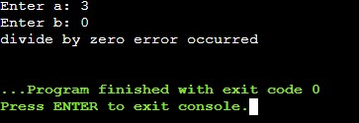

1. Write a C++ program to demonstrate the use of try, catch block with the argument as an integer and string using multiple catch blocks.:

| #include <iostream> using namespace std; int main() {  int choice;  int i = 12;  // char c;  cout<<"Enter choice: ";  cin>>choice;  try {  switch(choice){  case 1: throw i;  break;  case 2: throw 'i';  break;  case 3: throw "HelloWorld";  break;  }  }  catch(int x) {  cout<<"You chose 'choice = 1' and input integer"<<i<<endl;  }  catch(char y) {  cout<<"You chose 'choice = 2' and input character"<<i<<endl;  }  catch(const char *s) {  cout<<"You chose 'choice = 3' and input character array: "<<s<<endl;  }  return 0; } |
| --- |

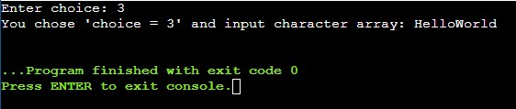

1. Create User defined exceptions to check the following conditions and throw the exception if the criterion does not meet. a) User has age between 18 and 55 b) User stays has income between Rs. 50,000 – Rs. 1,00,000 per month c) User stays in Pune/ Mumbai/ Bangalore / Chennai d) User has 4-wheeler

| #include <iostream> using namespace std;  class User{  int age, income;  string city;  bool hasVehicle;  public:  User(){  age = 0;  income = 0;  }    void getData(){  cout<<"Enter your age: ";  cin>>this->age;    if(this->age<18||this->age>55)  throw 1;    cout<<"Enter your income: ";  cin>>this->income;    if(this->income<50000||this->income>100000)  throw 2;    cout<<"Enter the city: ";  cin>>this->city;    if(this->city!="pune"||this->city!="mumbai"||this->city!="bangalore"||this->city!="chennai")  throw 3;    cout<<"Do you have a 4-wheeler? (Enter 1 for yes and 0 for no): ";  cin>>this->hasVehicle;    if(this->hasVehicle == 0)  throw 4;  } };  int main() {  User p1;  try{  p1.getData();  }  catch (int i) {  switch(i){  case 1: cout<<"Age is not in the desired range."<<endl;  break;  case 2: cout<<"Income is not in the desired range"<<endl;  break;  case 3: cout<<"City not as required by the statement."<<endl;  break;  case 4: cout<<"User does not have 4-wheeler."<<endl;  break;  }  }  return 0; } |
| --- |

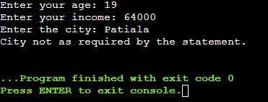

1. Write a C++ program to perform arithmetic operations on two numbers and throw an exception if the dividend is zero or does not contain an operator.

| #include <iostream> using namespace std;  int main() {  try{  float n1,n2;  char x;  cout<<"Enter the numbers: ";  cin>>n1>>n2;  if(n2==0)  throw(0);  try{  cout<<"Enter the operation you wish to perform: "<<endl;  cin>>x;  switch(x){  case '+':cout<<"the answer is :"<<n1+n2<<endl;  break;  case '-':cout<<"the answer is :"<<n1-n2<<endl;  break;  case '*':cout<<"the answer is :"<<n1*n2<<endl;  break;  case '/':cout<<"the answer is :"<<n1/n2<<endl;  break;  default:throw(x);  }  }   catch(char i){  cout<<"Exception occured: "<<x<<" is not a valid operator"<<endl;  }  }  catch(int i){  cout<<"Exception occured: Dividend is zero"<<endl;  }  return 0; } |
| --- |

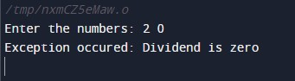

5. Write a program to implement the exception handling with the functionality of testing the throw restrictions.

| #include <iostream> using namespace std;  void f(int val) throw(int, double) {  if(val==0)   throw val;  if(val==1)   throw 'a';  if(val==2)   throw 123.23; }  int main() {  int val;  cout<<"Chose 0, 1 or 2: ";  cin>>val;  try{  f(val);   }  catch(int i) {  cout << "Caught an integer\n";  }  catch(char c) {   cout << "Caught char\n";  }  catch(double d) {   cout << "Caught double\n";  }  return 0; } |
| --- |

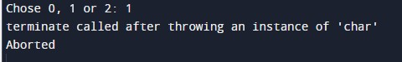

1. Write a program to implement the exception handling with re-throwing in exception

| #include<iostream> using namespace std; int main() {  int a,b;  try {  try {  cout<<"Enter values of two numbers: ";  cin>>a>>b;  if(a-b == 0)  throw a;  }  catch(int x)  {  cout<<"\nException in inner try-catch block.";  throw x;  }  }  catch(int n) {  cout<<"\nException in outer try-catch block.";  }  cout<<"\nEnd of program."; } |
| --- |

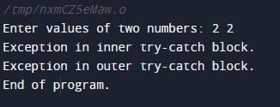

6. Write a C++ program to accept user name and password and throw an exception if the password has less than 6 characters or does not contain a digit

| #include <iostream> #include <cstring> using namespace std;  class user {  private:  string username,pass;  public:  user() {  username='0';  pass='0';  }  void getdata() {  cout<<"Enter the username: ";  cin>>username;  cout<<"Enter the password: ";  cin>>pass;  float x=pass.length();  if(x<6) {  throw 1;  }  int i=0,count=0;  while ( i<=x){  if(pass[i]>=48 && pass[i]<=57) {  count=1;  break;  }  else  i++;  }  if(count==0)  throw "Password does not contain a number!!";  } };   int main() {  user a1,a2;  try {  a1.getdata();  a2.getdata();  }  catch(int i) {  cout<<"Exception caught"<<endl<<"Length of password less than 6 numbers!!"<<endl;  }  catch(char const* s){  cout<<"Exception caught!!"<<endl<<s<<endl;  }  return 0;  } |
| --- |

